**STUDENT NAME:**

**DATE:**

1. **Linear Regression Model**

Summary of the Sales data

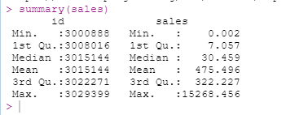

***Simple linear regression***

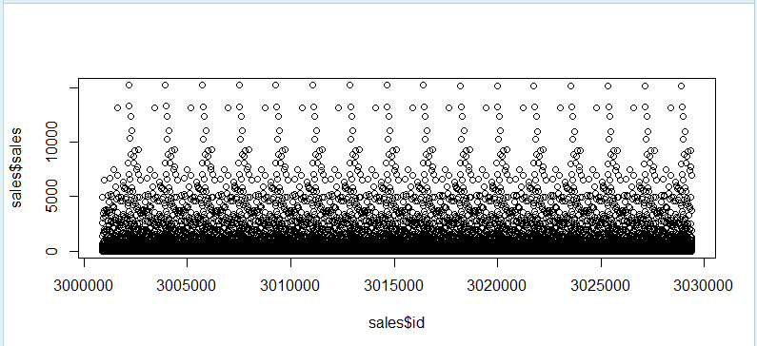

***Linear correlation***



1. **Random forest**

Load the dataset and make id as dependent variable

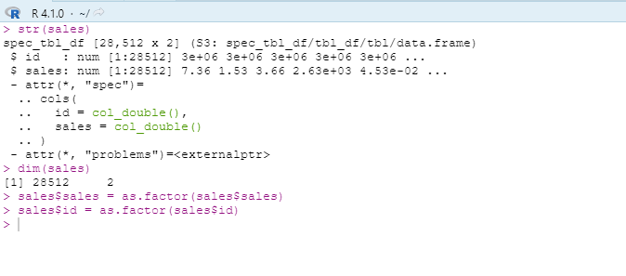



1. **CORRELATIONAL MODEL**
2. Getting the correlation between the ***store_nbr*** and the***cluster*** they belong to:
3. > stores <- read_csv("class/hello/papers/Data analysis with R/stores.csv")
4. Rows: 54 Columns: 5
5. -- Column specification -----------------------------------------------------------------------
6. Delimiter: ","
7. chr (3): id, sale
8. i Use `spec()` to retrieve the full column specification for this data.
9. i Specify the column types or set `show_col_types = FALSE` to quiet this message.
10. > View(stores)
11. > cor(sales$id, stores$sales)
12. [1] -0.05928399

Plotting the Correlation graphs:

> library(ggplot2)

> ggplot(sales) + aes(x = store_nbr, y = cluster) + geom_point(colur = "#0c4c8a")+ theme_minimal()

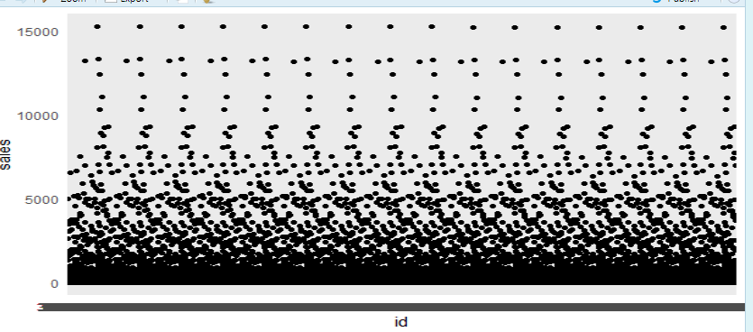

**Interpretation of the model**

In this lab, we have conducted a correlational analysis between two variables provided on the dataset. The correlation result produced is -0.05928399 meaning that there is no correlation whatsoever between the two values and that the values are independent of each other, the existent of one and a change in one does not affect the other. In this case, if store number changes, it does not affect in any way the relationship of the cluster of the rela*t*ionship

1. **TIME SERIES MODEL WITH ARIMA**

> View(sales)

> plot.ts(sales)

# GET THE TIMES SERIES

> library(ggplot2) ggplot(sales, aes(id, sales)) + geom_line()

> library(ggplot2)

> ggplot(sales, aes(id, sales)) + geom_line()

#PREDICT THE NEXT CLUSTER OF SHOPS OVERTIME

plot(diff(log(sales$sales)),type='l', main='log returns plot')

#STEP 4 STATIONARISE THE TIME SERIES

>adf.test(diff(log(as.numeric(sales$sales))), alternative="stationary", k=0)

#STEP 5 CALCULATE THE ACF PACF ON OUR DATASET BASED ON SHOP CLUSTERS

>acf(diff(log(sales$sales)))

>pacf(diff(log(sales$sales)))

#STEP 6

#CALL OUR FORECAST LIBRARY INSIDE ARIMA MODEL

> library(forecast)

> (fit <- arima(diff(log(sale$sales)), c(3, 0, 1)))

#FITTING OUR ARIMA

> fitARIMA <- auto.arima(diff(log(sales$sales)), trace=TRUE)

#CHECKNG TO SEE HOW OUR ARIMA MODEL FITTED WITH THE TRAINING DATASET

> plot(as.ts(diff(log(sales$sales))) )

> lines(fitted(fitARIMA), col="red")

#STEP 7

#MAKING A PREDICTION BASED ON OUR ARIMA MODEL

 >futurVal <- forecast(fitARIMA,h=5, level=c(99))

> plot(forecast(futurVal))

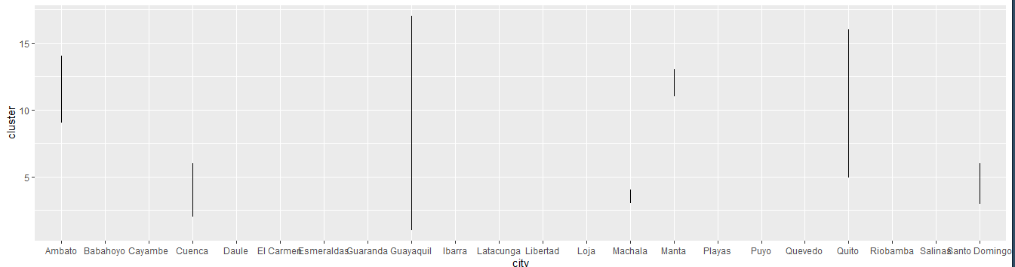

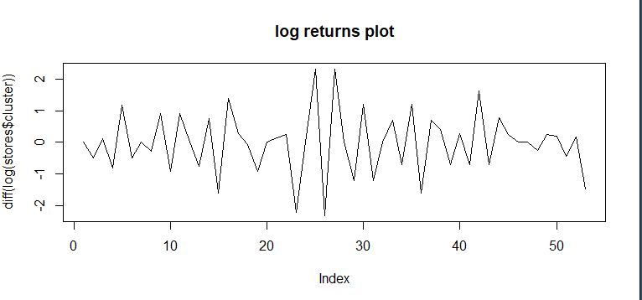

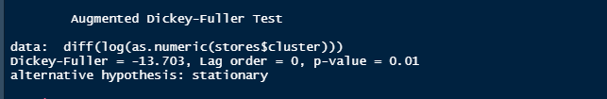

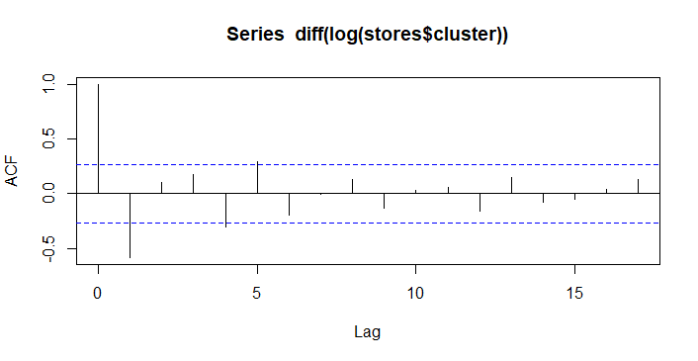

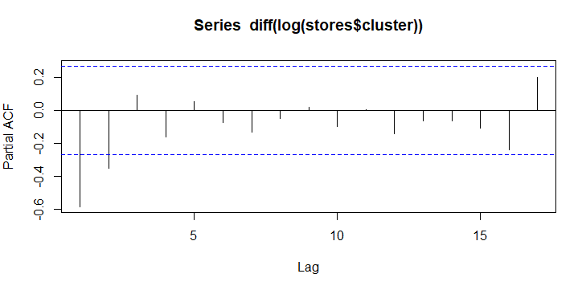

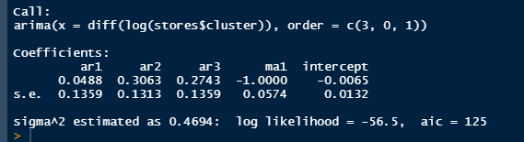

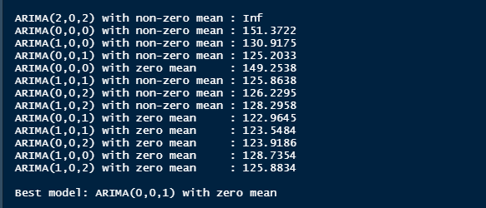

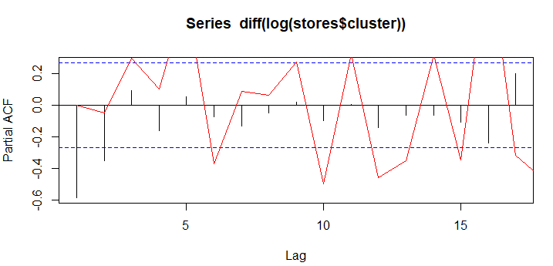

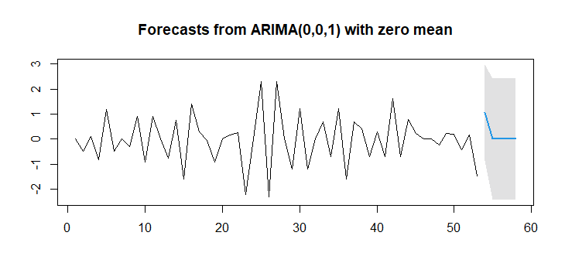

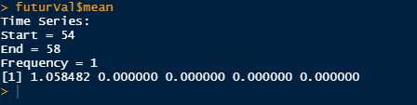

1. **RNN MODEL**

## STEP 3

 ##WE USE MOVING BLOCK SUB SAMPLING TO ENABLE US CUT OUR VECTOR INTO SMALL BITS FOR EASIER SAMPLING

> start_indexes <- seq(1, length(sales_type)- (max_len + 1), by = 3)

> cluster_matrix <- matrix(nrow = length(start_indexes), ncol = max_len + 1)

> for (i in 1:length(start_indexes)){cluster_matrix [i,] + max_len)]}

> for (i in 1:length(start_indexes))

{cluster_matrix [i,] <-store_type[start_indexes[i]:(start_indexes[i] + max_len)]}

#REMOVE WARNING MESSAGES

> dev.off()

null device

## STEP 4

#WE REMOVE N/A values and converting our matrix to NUMERIC

> for (i in 1:length(start_indexes))

{cluster_matrix [i,] <-store_type[start_indexes[i]:(start_indexes[i] + max_len)]}

> cluster_matrix <- cluster_matriX * 1

> cluster_matrix <- suppressWarnings(as.numeric(cluster_matrix) * 1)

> if(anyNA(cluster_matrix)){

+     cluster_matrix <- na.omit(cluster_matrix)

+ }

## STEP 5

#SEPARATE OUR DATA INTO PREVIOUS DAYS AND THEN DEFINE DAYS WE WANT TO PREDICT FOR THE STORE TYPE IN Y VARIABLE

X <- cluster_matrix[,-ncol(cluster_matrix)]

y <- cluster_matrix[,ncol(cluster_matrix)]

## STEP 6

# THIS INDEXING WILL SEPARATE OUR DATA INTO TRAINING AND TESTING UNITS

training_index <- createDataPartition(y, p = .9,

                                  list = FALSE,

                                  times = 1)

## STEP 7

# THEN TRAIN THE DATA

X_train <- array(X[training_index,], dim = c(length(training_index), max_len, 1))

y_train <- y[training_index]

## STEP 7

# THEN TEST THE DATA

X_test <- array(X[-training_index,], dim = c(length(y) - length(training_index), max_len, 1))

y_test <- y[-training_index]

## STEP 8

# DEFINE A NEW MODEL FOR THE STORES DATASET

stores_cluster_model <- keras_model_sequential()

# DEFINE NEW DIMENSIONS FOR INPUT DATA

dim(X_train)

## STEP 9

# THEN DEFINE INPUT LAYER OF THE MODEL

stores_cluster_model %>%

    layer_dense(input_shape = dim(X_train)[2:3], units = max_len)

stores_cluster_model %>%

    layer_simple_rnn(units = 6)

stores_cluster_model %>%

    layer_dense(units = 1, activation = 'sigmoid')

# TO GET A SUMMARY OF THE MODEL STRUCTURE USE summary command

summary(stores_cluster_model)

## STEP 10

# TRAINING THE MODEL

stores_cluster_training_model <- stores_cluster_model %>% fit(

    x = X_train,

    y = y_train,

    batch_size = batch_size,

    epochs = total_epochs,

    validation_split = 0.1)

## STEP 11

# PREVIEW THE MODEL

stores_cluster_training_model

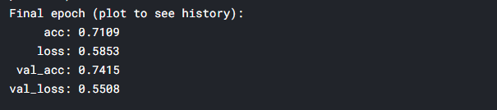

# PLOT THE RESULTING MODEL AS TRAINED

plot(stores_cluster_training_model)

